Billing system(Taiwan) procedure

Work flow description
  - Login procedure (Billing_Login)
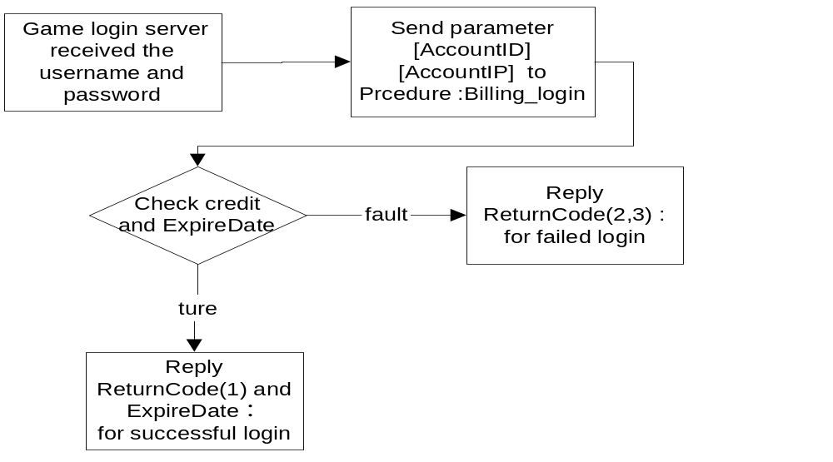

Input parameter ：
- AccountID ： member user name
- AccountIP ： member’s IP

Output String：returncode and expiredate
Default ExpireDate is null
- Expiredate format:Year-month-day hour:mins:second(ex:2002-9-11 15:30:20)
- Only returncode=1 (allow to login) can get this string not null.
- ExpireDate was been caculated by user’s credit,the rule of deduction defined in DB.Table[Billing_Rule].For example: 5 points per hour is our rule of deduction and John’s surplusage are 40 points, when he login at 2002-09-13 12:00:00 ,then his expiredate =2002-09-13 20:00:00.
- Game Server should kick out the user when she/he has expired.
- Game Server should notify the user before 30 mins ago when kicked out he/she.
Return code:
1：Allow to login to game server
2：the credit is no enough,please refill your credit. “點數不足，請重新儲值”
3：the credit is enough but the billing rule setting is not pay per hour，please show following Chinese message to client “你的計費方式不是計時制，請到儲值中心進行月費儲值或修改計費方式為計時制。”

ex：1,2002-09-13 17:25:32: allow to login to game server.

  - Logout procedure (Billing_Logout)
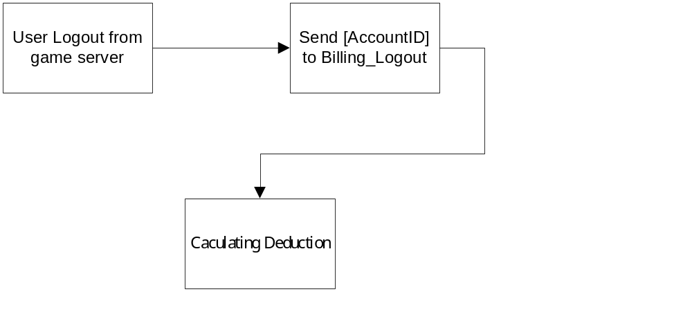

Input parameter：
- AccountID： member user name

No return code

